**COVID-19 VACCINES-ANALYSIS**

BATCH MEMBER

73252110 4701: **SRUSHTY A**

PHASE 3 SUBMISSION DOCUMENT

**PROJECT TITLE**:COVID 19 VACCINES ANALYSIS

**PHASE 3: DEVELOPMENT PART 1**

**TOPIC**

* In this part you will begin building your project by loading and preprocessing the dataset.
* Begin conducting the Covid-19 vaccines analysis by collecting and preprocessing the data.
* Collect and preprocess the Covid-19 vaccine data for analysis.

**INTRODUCTION**

The global battle against COVID 19 pandemic can be won only if a large part of the world gets vaccinated against the SARS-CoV-2 virus. A considerably low vaccination rate has been observed in low-income countries of the world. In this blog, we study the COVID 19 vaccination trends across the world using python, and we aim to derive key insights from the data which can help policymakers modify their policies.

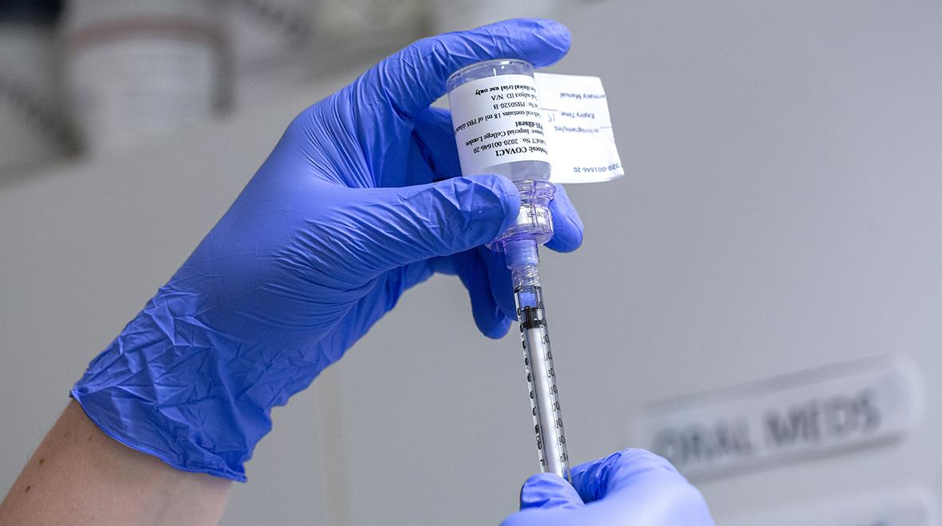

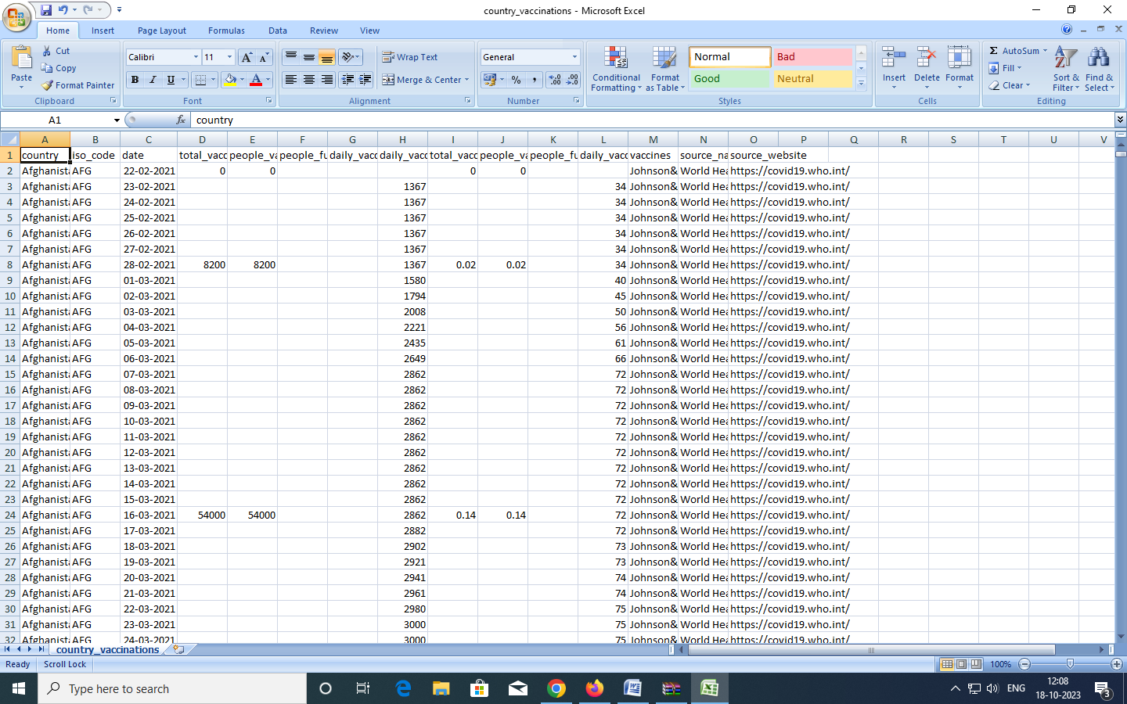

**DATA PRE _PROCESSING**

Data preprocessing needs because in the proposed work we get raw data with 16 attributes of twitter datasets. Data preprocessing removed the noisy and duplicated data and convert into the quality data. Data Preprocessing Removing the URLs, Data Filtering, Removing Special Characters, Removal of Retweets, Usernames, Remove Punctuations and symbols, Usage of Web links, Hashtags, Tokenization, Exclamation and question marks, Letter Repetition, Negations.

**NECESSARY STEP TO FOLLOW:**

1. IMPORT LIBRARIES:

Start by importing the necessary libraries:

PROGRAM

import seaborn as sns

import matplotlib

import matplotlib.pyplot as plt

%matplotlib inline

sns.set_style('darkgrid')

matplotlib.rcParams['font.size'] = 14

matplotlib.rcParams['figure.figsize'] = (9, 5)

matplotlib.rcParams['figure.facecolor'] =0

Explore the mean, min, max

In [13]:

vaccinations_df.mean()

/opt/conda/lib/python3.7/site-packages/ipykernel_launcher.py:1: FutureWarning: DataFrame.mean and DataFrame.median with numeric_only=None will include datetime64 and datetime64tz columns in a future version.

"""Entry point for launching an IPython kernel.

***OUTPUT****:*

total_vaccinations 2.315117e+07

people_vaccinated 8.451007e+06

people_fully_vaccinated 6.341251e+06

daily_vaccinations_raw 1.106083e+05

daily_vaccinations 1.308517e+05

total_vaccinations_per_hundred 4.041962e+01

people_vaccinated_per_hundred 1.953547e+01

people_fully_vaccinated_per_hundred 1.593274e+01

daily_vaccinations_per_million 3.245792e+03

year 2.021199e+03

month 6.165711e+00

day 1.571936e+01

dtype: float64

**LOAD THE DATASET**

* Dataset consist of weekly confirmed cases and

weekly cumulative confirmed cases for 35 weeks. Then the distribution of the data was examined using the most up-to-date Covid-19 weekly case data and its parameters were obtained according to the statistical distributions.

***PROGRAM***

data = pd.read_csv('case_time_series.csv')

**EXPLORATORY DATA ANALYSIS:**

Exploratory Data Analysis (EDA) is an analysis approach that identifies general patterns in the data. These patterns include outliers and features of the data that might be unexpected. EDA is an important first step in any data analysis of the covid 19 vaccines analysis.

**FEATURES:**

 COVID-19, such as fever, cough, sore throat, malaise, headache, muscle pain, nausea, vomiting, diarrhea, anosmia, or dysgeusia but without shortness of breath or abnormal chest imaging.

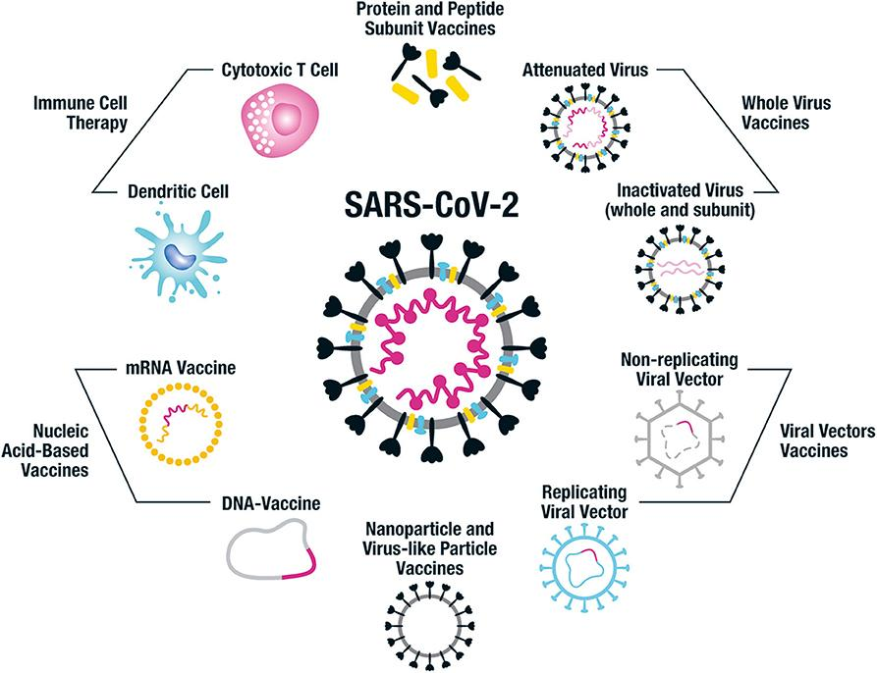

As the COVID-19 pandemic is entering its third year, it is known that the Omicron variant and its subvariant BA.2 are responsible for the increase in cases in India, mostly among those who have never been vaccinated. It's even causing infection in some vaccinated individuals. The positive side is that COVID-19 vaccinations are expected to remain efficient in preventing serious disease or hospitalization and deaths due to coronavirus.

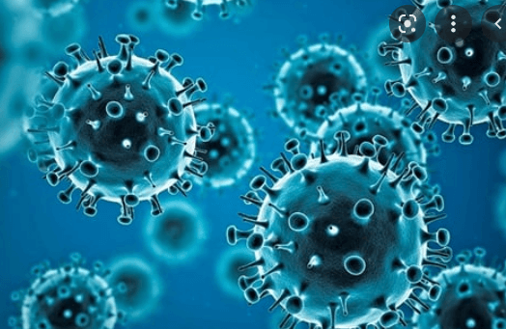

India has gone through three waves of the new coronavirus pandemic. The second one is the most destructive. It has caused severe damage with spiralling cases, decreased supplies of vital treatments, and increased deaths, particularly among the younger population, in India. Additionally, numerous cases of mucormycosis, also called "black fungus," have been reported in people with diabetes, those infected by COVID-19, and those who were recovering from the infection. The frequent use of steroids for the treatment of COVID-19 and immunosuppression led to the development of this fungal infection that opportunistic circumstances can trigger. The risk of the white fungus Aspergillosis--assumed to be even more fatal than the black fungus--is also on the rise, with some cases reported in parts of India. The risk of Aspergillosis (white fungus) is also prevailing and some cases have also been reported in parts of India. Its risk is assumed to be even greater than that of black fungus.

**PROGRAM**

| from cowin_api import CoWinAPI  from pprint import pprint  cowin = CoWinAPI()    pin_code = "796014"  date = '14-05-2021'  min_age_limit = 18  available_centers = cowin.get_availability_by_pincode(pin_code, date)  print("All Available Centers [ By Pincode ] : ")  pprint(available_centers) |
| --- |

**ANALYSIS:**

From the above Visualization find some interesting points that are mentioned below.

* China is the number 1 Total Vaccinated people are present
* The Dataset is available for 2021 and 2022.
* The Total of 223 Countries participated in Vaccination.
* IN 2021 Total Vaccination is 60.79% completed.
* In 2022 Total Vaccination is 39.2% is completed.
* China, India, the United States, Brazil, Indonesia, Germany, United States, Turkey, France, and England There are the top 10 countries is completed the full Vaccinations.

***CONCLUSION:***

In Conclusion, we can take look at the Dashboard for further Analysis.

* In China and India in these two countries, most people are Vaccinated.
* In 2021 60.79% of people are fully Vaccinated and in 2020 only 39.2 % of people are fully Vaccinated.
* China, India, the United States, Brazil, Indonesia, Germany, the United States, Turkey, France, and England There are the top 10 countries is completed the full Vaccinations.